**Design application for Library Management System**

We want to develop the application for library Management system

**Objective of project**

The main objective of this project is to develop the application using library management and, in this project, we have two users one is librarian and one is student

**Task of library**

a.     Add new student list in database using array of objects & provide login here we consider email is username and contact is password

b.    Add a new list of books in the database using an array of objects.

c.     View All Students

d.    Search student by name or email

e.    View All Books

f.      Search books by name or email

g.     View issued book by student

h.    View student who issues minimum single book

i.       Show the total number of books in library

j.       Show the available book count in library

k.     Show the issued book count in library

**Task of students**

a.     Login in system using email and contact

b.    View all books

c.     Issue book but if book already issue then show the message book is already issued

d.    Show the own profile and student can edit it

e.    Show self-issued book list

f.      Show the total book count in library

g.     Show the available books student can issue

h.    Return book to library

i.       Logout

**Refer following diagram**

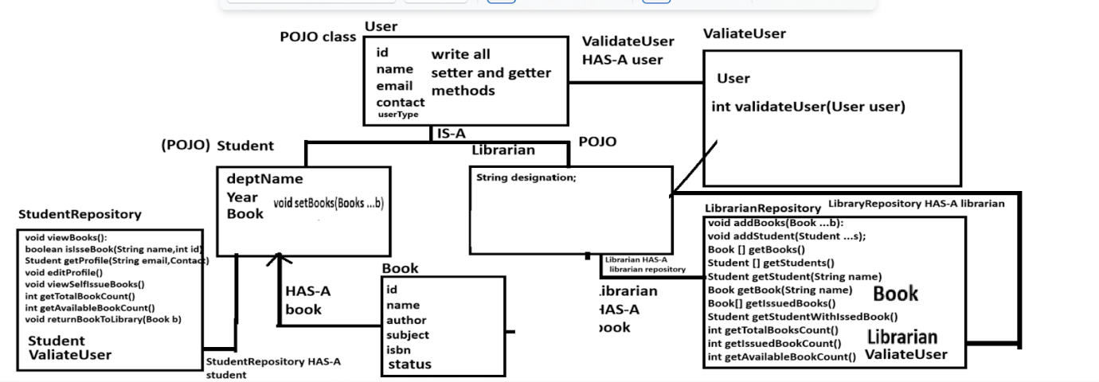

**Classes and methods description given below**

class User

{

  private int id;

  private String name;

  private String  email;

  private String contact;

  private String userType;

 //write here setter and getter methods

  public User(){

  }

  public User(int id,String name,String email,String contact,String userType)

  {

  }

}

class Student extends User

{  String deptName;

   String year;

//write here setter and getter for deptName and year

   public Student()

   {

   }

   public Student(String deptName,String year)

   {

   }

   Book book[];

   void setBooks(Book ...book)

   Book [] getBooks():

}

class Librarian extends User

{

     private String designation:

  //write here setter and getter method for designation

}

class ValidateUser

{

   public int validateUser(User user)

   {

      // check the user login

   }

}

Note: we consider email of student as username and contact of user as password so you can check

user login using email and contact

Book.java

___________________________________________________

class Book

{

   private int id;

   private String name;

   private String author;

   private String subject;

   private String isbn;

   private Boolean status;

   public Book(){

    }

   public Book(int id,String name,String author,String subject,String isbn,booean status)

   {

   }

 //write setter and getters for book

}

LibrarianRepository.java : this class help us to write logic for librarian activity means after librarian login

developer can write all librarian logics in this class.

void addBooks(Book []b): this method can accept array of object as parameter and store data for next process

and book should not be added in array of objects repeatedly and set status of every book as false when added by librarian

void addStudents(Student s[]): this method can accept student objects and store in array of object for next uses or process.

Book [] getBooks(): this method can return all books detail.

Student [] getStudents(): this method can return all student list to librarian

Student[] getStudentName(String name): this method can return student list by name

Book getBook(String bookName): this method can return book detail by name

Book[] getIssuedBooks(): this method can return only issued books

Student [] getStudentWithIssedBook(): this method can return student list with issued books.

int getTotalBookCount(): this method can return total book count which is present in library

int getIssuedBookCount(): this method can return total issued books count

int getAvailableBookCount():this method can return total available book which we can issue

StudentRepository.java: this class  help us to write logic for student activity means after student login

developer can write all student logics in this class.

class StudentRepository

{  Book book[];

 void viewBooks(): this method show the books to students which is not issued

 Book issueBook(String name,int id): this method can accept book name and id and issued book means change status as true when book issued

 Student getProfile(String email,String contact): this method accept email and contact and return student profile.

 void editProfile(): student can change own profile

 void viewSelfIsseBooks(): this method can show the self issued book list to student

  int getTotalBookCount(): this method can return total book count which is present in library

  int getIssuedBookCount(): this method can return total issued books count

  int getAvailableBookCount():this method can return total available book which we can issue

  void returnBookToLibrary(Book b): this method can return book to library means change the     status of book as true.

}